NEW MEXICO

Office of Substance Abuse Prevention

ASSESSMENT TRAINING

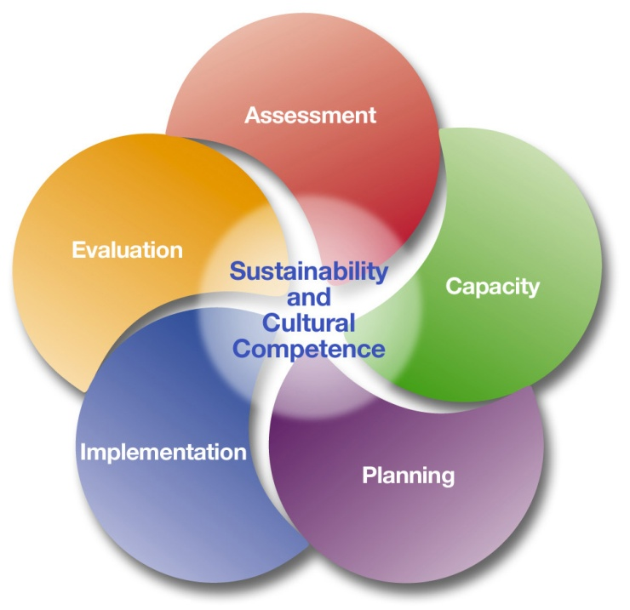

Funding for this training comes from the New Mexico Behavioral Health Services Division – Office of Substance Abuse Prevention (New Mexico Human Services Department). For questions, please contact: Karen Cheman, MPH (Staff Manager, NPN & SEOW Director), karen.cheman@state.nm.us, Office of Substance Abuse Prevention, BHSD/HSD, 37 Plaza La Prensa, Santa Fe, NM 87507, 505-476-9270.
Assessment Training
Agenda

Welcome & Introductions
Overview of Strategic Prevention Framework
Overview of Community Needs Assessment
Introduction of Logic Models
Quantitative Data Collection Guidance and Sources
Qualitative Data Collection Guidance (FG guide)
Development of Data Collection Plan
Introduction of Data Information System
Review of Assessment Report
Next Steps

Training Description
This training will provide an overview of the Strategic Prevention Framework (SPF) in order to gain an understanding of the theory of change used by the Office of Substance Abuse Prevention (OSAP) to address problems related to alcohol abuse and prescription opioid abuse. Participants will learn how to conduct an assessment around substance abuse priorities, use a logic model, implement effective focus groups, design a data collection plan, identify how to gather representative data, use OSAP-developed data collection tools, and create an action plan for completing a community-wide assessment.

Participants will leave the training with an understanding of the SPF and
an action plan for completing the OSAP Assessment Report
Training Objectives
- Define SPF Terminology
- Use a logic model to guide data collection
- Use a data information system to enter and track quantitative data
- Understand data related to alcohol and prescription drugs
- Review data collection tools
- Describe key factors in conducting focus groups and interviews
- Design a data collection action plan

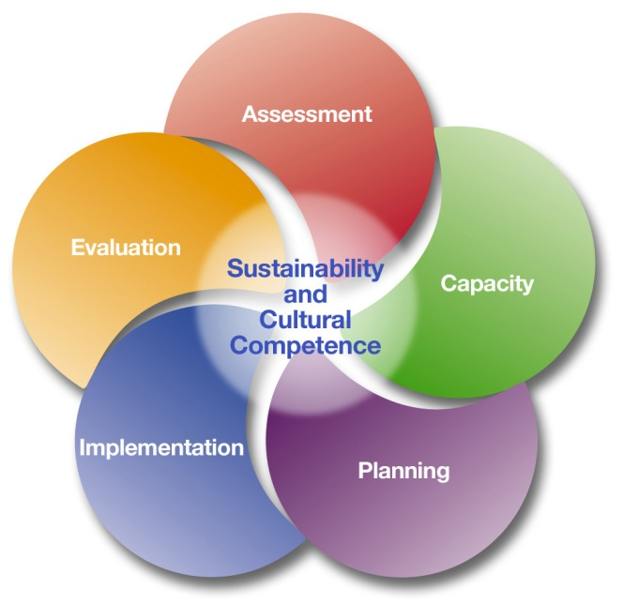

SFP Step | Key Components
Assessment | Gather data on priority issues that can be used to assist in making informed strategic decisions  - Identify data sources  - Develop data collection plan  - Develop / Identify data collection tools  - Gather and compile data around priority areas and community factors  - Analyze data and compile a report  - Use data to identify needs, and risk and protective factors  - Use data to begin prioritizing populations, risk factors, intervening variables, and contributing factors
Capacity | Build or increase the ability of individuals and organizations to effectively address the priorities and needs identified in the assessment  - Convene stakeholders and leaders  - Build partnerships and obtain MOUs  - Identify and participate in training and education  - Organize provider networks  - Mobilize resources (human, financial, organizational)  - Leverage resources to help sustain efforts and outcomes  - Identify coalition strengths and needs  - Incorporate culturally appropriate means for recruiting community partners  - Assess community readiness and develop plans to increase readiness

SFP Step | Key Components
Planning | Use data from the assessment, capacity, and readiness to identify strategies that will have the greatest impact on priority areas  - Articulates a vision for prevention initiatives  - Identifies benchmarks and timeframes  - Clearly states goals and measurable objectives for reaching outcomes  - Identifies programs, policies, or practices  - Uses logic models to guide work  - Involves input from multiple stakeholders, coalition members and the community
Implementation | Carry out every step of the SPF and turn the strategic plan into action  - Monitor implementation and make quality improvements as necessary  - Hold stakeholders accountable to work promised  - Adapt process or plan as needed
Evaluation | Monitor the process and measure effectiveness of programs, policies or practices  - Develop an evaluation plan that connects to each goal and objective  - Track indicators (process and outcome)  - Complete evaluation reports  - Present findings and progress
Cultural Competence | Meaningfully include everyone who will be impacted by your prevention efforts (including data collection, tool development, reporting, prioritization, planning, implementation and evaluation)  - Incorporate representation from every subgroup and cultural group in your community  - Adapt processes according to cultures, languages, needs, and values of community  - Consider disparities and how to address them respectfully
Sustainability | Consider the multiple factors that contribute to project success—such as the existence of stable prevention infrastructure, available training systems, and community support—and work toward maintaining these  - Supportive policies and procedures that build capacity  - Securing resources to build capacity  - Acquire expertise needed for SPF and strategic plan  - Develop and nurture broad community support  - Develop stakeholders into system leaders and champions  - Develop sustainability plan

SPF Definitions
Below are some of the terms that will be used in your prevention work, many of the terms are related to the Strategic Prevention Framework.
Logic Model | A tool for strategic planning that identifies the problems that the local prevention effort wishes to reduce. This tool also specifies strategies selected by the community that have been shown to change intervening variables and the measures to monitor changes in those variables.
Intervening Variable | Factors that have been identified to strongly influence the occurrence and magnitude of substance abuse and its related problems.
Retail Access | Obtaining prescription opioids through retail markets (medical providers/prescribers).  Obtaining alcohol through retail markets (bars, restaurants, stores, etc.)
Activity (Action Steps) | Purposeful and planned meetings, interventions, events and activities by the environmental prevention project to implement strategies (e.g. Alcohol: meeting with law enforcement, obtaining resources to conduct or increase local drinking and driving enforcement. E.G. Rx painkillers: meeting with pharmacists to develop informational pamphlets around the dangers of prescription opioid misuse to be distributed to parents of young athletes).
Strategy | A method or plan chosen to bring about a desired future, such as achievement of a goal or solution to a problem.
Goal (Outcome) | The specific alcohol or opioid problem to be changed through the local environmental prevention effort, such as high risk drinking over the past 30 days, or a consequence of use such as alcohol-related traffic crashes.
Low Enforcement | Insufficient enforcement of existing regulations, policies, and laws.
Social Access | Obtaining prescription opioids through social sources (e.g. friends, family, parties, etc.).  Obtaining alcohol through social sources (e.g. friends/near peers, family/parents/grandparents/siblings, parties, etc.)
Contributing Factor | Factors that have been identified to strongly influence the occurrence and magnitude of substance abuse and its related problems.
Perception of Risk | Belief held (whether rational or irrational) by individuals, groups, or societies about the chance, or severity or risk.

Community Assessment

What Is a Community Assessment?

A community assessment is a comprehensive description of your target community. It provides a general “lay of the land” in order to help you:

- Target real problems specific to your community
- Capitalize on existing efforts and resources
- Implement desired practices and policies

Empirical quantitative and qualitative data—based both on observation and factual information—can show what is happening, where it is happening, to whom, and why. Anecdotal evidence or data collected with little rigor may only show a part of the larger picture.

What Are the Goals of a Community Assessment?

The goals of a community assessment are to:

- Develop community awareness about ATOD problems in the community
- Identify underlying factors that contribute to these problems
- Analyze environmental factors that contribute to these problems
- Establish baseline data to track the coalition’s progress

Having someone in the coalition who understands and has access to data will help build the capacity of the coalition—and it will also increase support for planning, implementation, and sustainability. In the OSAP model, the local evaluator often serves the role of helping coalition members and working with data towards these ends.

Logic Models

What Is a Logic Model?
"Logic models are a visual method of presenting an idea. They offer a way to describe and share an understanding of relationships among elements necessary to operate a program or change effort. Logic models describe a bounded project or initiative: both what is planned (the doing) and what results are expected (the getting). They provide a clear roadmap to a specified end." (The Logic Model Guidebook. Knowlton and Phillips).
Using a Logic Model for Environmental Prevention
Logic models lay out the community substance abuse problem and the key markers leading to that problem. They represent systematic plans for attacking local problems within a specific context. The community logic model makes explicit the rationale for selecting programs, policies, and practices to address the community’s substance abuse problem. Used in this way, the logic model becomes an important conceptual tool for planning a comprehensive and effective prevention effort.
Basic Logic Model for Environmental Prevention
Outcome – The specific problem to be changed through the local environmental prevention effort, such as high risk drinking over the past 30 days, or a consequence of use such as alcohol-related traffic crashes.
Intervening Variable (IV) – Factors that directly or in combination cause or contribute to a problem and that must be changed in order to achieve a prevention outcome.
Strategy – An environmental prevention action, such as drinking and driving enforcement, that has been shown to change intervening variables in order to reduce alcohol and other drug problems and achieve the desired outcome.
Action Step – Purposeful and planned meetings, interventions, events and activities by the environmental prevention project to implement one or more specific strategy, e.g., meeting with law enforcement or obtaining resources to conduct or increase local drinking and driving enforcement.

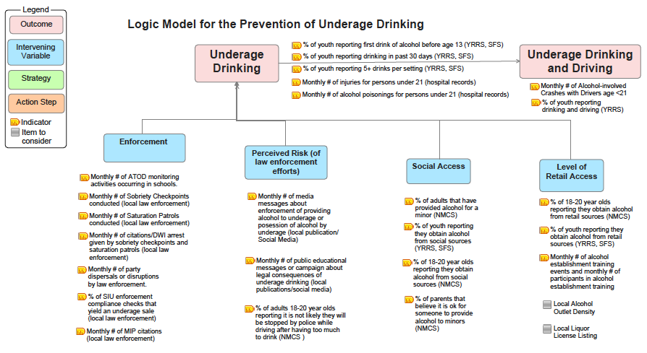
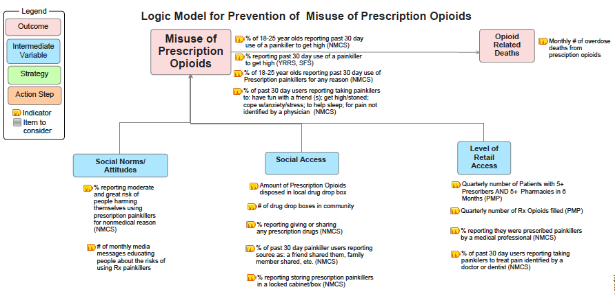

Quantitative Data Sources

Key Data Sources for Community Substance Abuse Prevention
American Community Survey (ACS)

https://www.census.gov/programs-surveys/acs/about.html

The American Community Survey (ACS) helps local officials, community leaders and businesses understand the changes taking place in their communities. It is the premier source for detailed information about the American people and workforce.

National Survey on Drug Use and Health (NSDUH)

http://www.samhsa.gov/data/population-data-nsduh

The National Survey on Drug Use and Health (NSDUH) is the primary source of information on the prevalence, patterns, and consequences of alcohol, tobacco, and illegal drug use and abuse and mental disorders in the U.S. civilian, non-institutionalized population, age 12 and older. The survey generates estimates at the National, state, and sub-state levels.

New Mexico Community Data Collaborative (NMDC)

http://nmcdc.maps.arcgis.com/home/

The New Mexico Community Data Collaborative (NMDC) develops and shares neighborhood data with local organizations that promote community assessment, child health and participatory decision-making. The website contains maps and files organized by sub-county areas such as census tract, zip code, school district and other administrative boundaries. In addition, users will find site-specific information for public schools, licensed facilities and other public services. The interactive functions of ArcGIS Online facilitate group exploration of health and education issues. The NMDC offers workshops and trainings for those interested in exploring and making the maps.

The New Mexico Community Survey (NMCS)

http://www.nmprevention.org/Evaluation-Instruments.html

The New Mexico Community Survey (NMCS) is a survey instrument used to measure change in adult ATOD-related behaviors and intervening variables on a community-level. Implemented annually in the spring by NM OSAP prevention programs, the survey can be completed on paper, via online browser, or, since 2016 by using a Qualtrics app on tablets. The NMCS is an important way that OSAP programs are able to evaluate their progress on addressing intervening variables and consumption outcomes on an annual basis in real time.

Data are only available via direct communication with the implementing prevention program. Protocols, instruments, data entry templates, and syntax for analysis are available on the www.nmprevention.org website. Program contact information is also available on the prevention website.

New Mexico’s Indicator-Based Information System (NM-IBIS)

https://ibis.health.state.nm.us/

NM-IBIS is your source for data and information on New Mexico's priority public health issues. The mission of the New Mexico Department of Health is to promote health and wellness, improve health outcomes, and assure safety net services for all people in New Mexico. NM-IBIS provides access to the data that can help provide outcome measures for the health goals of New Mexico, and includes reports on specific health topics as well as the ability to query datasets to create your own maps and charts. There is open access to the public to make direct queries of available data, and NMDOH can provide you direct support in how to make queries and explore maps.

New Mexico Substance Abuse Epidemiology Profile (NM SAEP)

http://nmhealth.org/about/erd/ibeb/sap/

The New Mexico Substance Abuse Epidemiology Profile is a tool for substance abuse prevention planners at the state, county, and community level. Its primary purpose is to support efforts related to the Statewide Epidemiological and Outcomes Workgroup (SEOW). The SEOW is intended to develop resources to help communities conduct needs assessments regarding substance use and its consequences; build capacity to address those needs; and plan, implement, and evaluate evidence-based programs. Updated annually, data are available by county, for the state and for some variables in relation to the US.

New Mexico Youth Risk and Resiliency Survey (YRRS)

http://www.youthrisk.org/

The New Mexico Youth Risk and Resiliency Survey (YRRS) is a tool to assess the health risk behaviors and resiliency (protective) factors of New Mexico high school and middle school students. The YRRS is part of the national CDC Youth Risk Behavior Surveillance System (YRBSS).

Topic areas for the YRRS include risk behaviors related to alcohol and drug use, unintentional injury, violence, suicidal ideation and attempts, tobacco use, sexual activity, physical activity, and nutrition; resiliency (protective) factors such as relationships in the family, school, community, and with peers; and health status issues such as body weight and asthma.

Conducted in November of every odd-numbered year, results are available online by county and for those with permission, by school and school district when requested directly. County reports include results by grade, gender, in comparison to New Mexico, and trends over time.

Prescription Drug Monitoring Program (PDMP) or Prescription Monitoring Program (PMP)

http://www.nmpmp.org/

The New Mexico Prescription Monitoring Program (PMP) accumulates Schedule II-V controlled substance prescription and dispensing information into a restricted access online database in order to meet its mission to reduce the diversion of these controlled substances while serving as a valuable tool for legitimate medical practice and patient care. All Practitioners (excluding Veterinarians) licensed in the state of New Mexico are required to have an account with the PMP. County-level PMP data must be accessed by contacting NMDOH Epidemiologists participating in the SEOW.

Strategies for Success (SFS)

http://www.nmprevention.org/Evaluation-Instruments.html

The Strategies for Success (SFS) is a survey instrument originally designed to assess changes in ATOD use among NM-OSAP providers. There are two SFS tools, one that is conducted annually, typically used by PFS communities and those implementing environmental prevention strategies only, and one that is specifically for use with direct service prevention programs in grades 6 through 12, and is a baseline/post version of the survey. Module-based, there are middle and high school versions of the core survey (Module A), which focuses on basic demographics and ATOD-specific questions regarding consumption, personal beliefs, social access, and perception of risk. Modules B-E focus on internal and external resiliency, and violence victimization and perpetration. Many questions are comparable to those used in the YRRS/YRBSS so that results are comparable, but data and findings are only available via direct communication with the implementing prevention program or PIRE.

New Mexico Student Lifestyles Survey (SLS)

http://evaluationspecialists.com/clients/ (School password needed to access data)

The Student Lifestyle Survey (SLS) is an annual survey that includes measures of alcohol, tobacco, and other drug (ATOD) use behaviors and attitudes from almost 3,000 students at six colleges from the New Mexico Higher Education Prevention Consortium. The consortium members include Eastern New Mexico University, New Mexico State University, New Mexico Institute of Mining and Technology, Santa Fe Community College, San Juan College and the University of New Mexico.
Collecting Qualitative Data
IMPORTANT TO KEEP IN MIND FOR THIS PREVENTION ASSESSMENT:
Do not publically disseminate data collected until your STRATEGIC plans are complete

FOR QUALITATIVE DATA COLLECTION
Use the form below to summarize your focus group or interviews, so you can easily track the data you. An example is provided below:
- Tools can be modified, but try to ask all the questions currently included in the script. If you wish to add questions, check with PIRE and your evaluator for review.
- Never use video to record interviews or focus groups and do not publically disseminate quotes, photos, or other identifying information collected.
- Always provide informed consent (see template below)- verbal is ok for those 18 or older.
- Always get passive or active parental consent for youth under 18.
- Do not count responses from a focus group or set of interviews. Your sample is not representative and the point is to generate conversation.
- Avoid encouraging people to talk about their personal use/abuse or those of anyone identifiable to others (unless a public figure).
- You are not the expert: your participants are.
- Carefully review each script before conducting a focus group or interview so you can make sure to frame the questions best for your population.
- Document the process of conducting the focus group using a similar structure as the following example.

EXAMPLE: Qualitative data collection log - Focus Group or Interview Protocol: Youth At Risk 14-17
Date: 5-15-2016 | Location: Coffee Shop
Population: Youth involved in the JPPO programming | Name/affiliation of interviewer: Liz Lucha, prevention coalition evaluator
Number of people attending: 6 boys and 1 girl | Name/affiliation of scribe: JuanCa Libre, prevention coalition coordinator
How participants recruited & incentives: “snowball sampling” starting with two volunteers recruited through JPPO who invited others to participate. Participants given a $20 gift card and a meal at the café.
Issues, concerns and insights: Only 3 participants showed initially, but with more efforts, others began to join. After the focus group was over we spent about another hour addressing questions about the prevention program and what it entailed.

Data Collection Plan

The Data Collection Plan is a practical tool for identifying the most valuable data to be collected during an assessment phase and beyond. The Local Data collection Plan identifies the specific Indicators (taken from the logic models); the frequency with which the data will be collected, e.g., monthly, annually, etc.; the source of the data; and notes (additional information relevant to that specific indicator).
Below are examples of data collection plans for underage drinking and prescription painkillers that list the specific indicators that are to be collected. Please modify this general data collection plan to fit the local situation. This means both removing some of these indicators and adding additional indicators as needed.
EXAMPLE Local Data Collection Plan: Underage Drinking
Indicator | Frequency | Source | Notes
Outcomes
% of youth reporting first drink of alcohol before age 13 | Bi-annually for YRRS | YRRS
% of youth reporting drinking in the past 30 days | Bi-annually for YRRS and annually for SFS | YRRS, SFS | SFS data is not available in our community.
% of youth reporting 5+ drinks per setting | Bi-annually for YRRS and annually for SFS | YRRS, SFS
Monthly # of injuries for persons under 21 | Monthly | Hospital records
Monthly # of alcohol poisonings for persons under 21 | Monthly | Hospital records
Retail Access
% of youth reporting they obtain alcohol from retail sources | Bi-annually for YRRS and annually for SFS | YRRS, SFS
% of 18-20 year olds reporting they obtain alcohol from retail sources | Annually | NMCS
% of SIU enforcement compliance checks that yield an underage sale | Monthly | Local law enforcement
Social Access
% of youth reporting they obtain alcohol from social sources | Annually | YRRS, SFS
% of 18-20 year olds reporting they obtain alcohol form social sources | Annually | NMCS
% of adults that have provided alcohol for a minor | Annually | NMCS
Enforcement
Monthly # of party dispersals or disruptions by law enforcement | Quarterly | Local law enforcement
Monthly # of sobriety checkpoints conducted | Monthly | Local law enforcement | This data may not be available on a monthly basis.
Monthly # of citations/DWI arrests given by sobriety checkpoints | Monthly | Local law enforcement
EXAMPLE Local Data Collection Plan: Underage Drinking
Indicator | Frequency | Source | Notes
Perceived Risk (of law enforcement efforts)
Monthly # of media messages about enforcement of providing alcohol to underage or possession of alcohol by underage | Monthly | Local newspaper, Social Media
% of adults 18-20 years old reporting it is not likely they will be stopped by police while driving after having too much to drink | Annually | NMCS
% of adults reporting somewhat or very likely police will arrest an adult for providing alcohol to a minor. | Bi-annually | Brief community survey

EXAMPLE Local Data Collection Plan: Prescription Painkillers
Indicator | Frequency | Source | Notes
Outcomes
% of 18-25 year olds reporting past 30 day use of a painkiller to get high | Annually | NMCS
Social Norms/Attitudes
% reporting moderate and great risk of people harming themselves using prescription painkillers for nonmedical reason | Annually | NMCS
Social Access
Amount of prescription opioids disposed in local drug drop box | Quarterly | Organization tasked with dispensing drug drop box
% reporting giving or sharing any prescription drugs with someone that was not prescribed them. | Annually | NMCS
Retail Access
% reporting they were prescribed painkillers by a medical professional in the past year | Annually | NMCS
Patients with 5+ Prescribers AND 5+ Pharmacies in 6 Months | Quarterly | PMP Data | County level data

Specific Recommendations for Data Management
- Designate a Data Point Person
Designate a local data manager who is responsible for implementation of the data collection plan and for updating the data information system. The manager can be a staff person, coalition member, or an informed volunteer (a single person who oversees the data information system) who will assume full accountability.
- Be Consistent When Entering and Updating Data
The data collection approach should be consistently (and frequently) applied. The approach used to collect local measurements should be used consistently. Changing from one approach to another approach can yield different and inconsistent results.
- Update the Data Information System on a Monthly Basis (If Data Is Available)
Update the data information system with all available data, at least monthly, as a part of project routine. Even if there are significant data missing, this should be routinely entered. Monthly review of the MIS reinforces the importance of such data in support of effective environmental prevention.
- Don’t Collect More Data Than Necessary
Collect specified data only. Since ALL necessary local data are specified in the strategic planning process, and a routine part of effective prevention, only essential data should be collected. Avoid collecting data based on simple availability.
- Make a Note When Data Isn’t Available
Data specified in the logic model that have never been collected should be noted, as well as every effort made to develop new approaches to collecting this data. This is especially true for measurement of key intervening variables or strategies where missing data leaves the staff and the coalition blind to any possible changes in patterns and levels.
- Be Aware of Random Variation in the Data
Random events in a community can impact local data, even if collected consistently. For example, in a small population, fatal traffic crashes with alcohol involvement can occur infrequently. Multiple vehicle crashes in one month can result in a significant jump in the crash statistics for that month. Such variations are normal and typically no reason for concern if there is no change in data collection methods.
- Celebrate the Small Wins
Data collection can be tedious, and sometimes boring. Make every effort necessary to stimulate, reward, and motivate staff and volunteers who are collecting and entering the local data. Print and review the data information system at least monthly in order to reinforce its importance.
Assessment Report Template

Assessment Report
New Mexico Office of Substance Abuse Prevention Grantees

Assessment Report Timeline | Date*
Section I Complete | September
Section II Complete | October
Final Report (Section I-III) Due | December
* Dates are subject to change

Coalition Name:

Project Director:
Program Coordinator:
Other Staff:

Briefly describe your coalition
Key Members:
Core Team Members:
Key accomplishments to date (highlights):
Challenges or barriers experienced:

Section 1*
*Example Format - Section 1 will be created in excel spreadsheet

Directions:

- Refer to your community’s Youth Risk and Resiliency Survey (YRRS) results, your campus’s Student Lifestyles Survey (SLS), the New Mexico Community Survey (NMCS) the most recent Census data and the New Mexico Substance Abuse Epidemiology Profile (NM SAEP) to complete the following data tables.
- After you complete the tables, review the data and provide a brief summary of the trends in your local community. Specifically consider the following questions:
  - What do the data suggest about the prevalence of underage drinking and prescription painkiller misuse in your community (both on and off campus)?
  - Are there any changes positively or negatively between years and/or subgroups?

County Demographics
 |  |  |  |  |  | Data Source
Demographics
Population |  |  | [COUNTY] | New Mexico | United States
 | Total Population |  |  | 2,059,179 | 308,745,538 | 2010 Census
 | Age 15-19 |  |  | 149,861 | 22,040,343
 | Age 20-24 |  |  | 142,370 | 21,585,999
Race (One Race) |  |  | [COUNTY] | New Mexico | United States
 | White |  |  | 68.4% | 72.4% | 2010 Census
 | Black of African American |  |  | 2.1% | 12.6%
 | American Indian and Alaska Native |  |  | 9.4% | 0.9%
 | Asian |  |  | 1.4% | 4.8%
 | Native Hawaiian and Other Pacific Islander |  |  | 0.1% | 0.2%
 | Some Other Race |  |  | 15.0% | 6.2%
Hispanic or Latino |  |  | [COUNTY] | New Mexico | United States
 | Hispanic or Latino (Of Any Race) |  |  | 46.3% | 16.3% | 2010 Census
 | Not Hispanic or Latino |  |  | 53.7% | 83.7%
Education |  |  | [COUNTY] | New Mexico | United States
 | Percent High School Graduate or Higher |  |  | 84.0% | 86.3% | 2014 ACS
 | Bachelor's Degree or Higher |  |  | 26.1% | 32.4%
Income |  |  | [COUNTY] | New Mexico | United States
 | Median Household Income |  |  | $44,968 | $53,482 | 2014 ACS
 | Income Below Poverty Level (Past 12 Months) |  |  | 20.9% | 15.6%

Campus Demographics

[Please add additional information on student demographics for your campus. e.g. total enrollment, age, race, ethnicity, gender, etc.]

Summary of Trends
- Add example

Priority: Prevention of Underage Drinking
 |  | 2005 | 2007 | 2009 | 2011 | 2013 | 2015 | Data Source
Percent Who Currently Drink (Past 30 Days)
Youth Grades 9-12
 | [COUNTY] |  |  |  |  |  |  | YRRS HS
 | New Mexico | 42.3 | 43.2 | 40.5 | 36.9 | 28.9
 | United States | 43.3 | 44.7 | 41.8 | 38.7 | 34.9
Percent Who Binge Drink (Past 30 Days)
Youth Grades 9-12
 | [COUNTY] |  |  |  |  |  |  | YRRS HS
 | New Mexico | 28.6 | 27.4 | 25.0 | 22.4 | 20.8
 | United States | 25.5 | 26.0 | 23.4 | 21.9 | 17.1

 |  | 2011 | 2012 | 2013 | 2014 | 2015 | 2016 | Data Source
Percent Who Currently Drink (Past 30 Days)
University Population
 | [SCHOOL NAME] |  |  |  |  |  |  | SLS
 | NMHEPC |  |  |  |  | 57.1
Percent Who Binge Drink (Past Two Weeks)
University Population
 | [SCHOOL NAME] |  |  |  |  |  |  | SLS
 | NMHEPC |  |  |  |  | 30.7

Percentages of Alcohol Use Outcomes by Age Groups among All Respondents
New Mexico 18-25 Year Olds |  | Past 30-day alcohol use | Past 30-day binge drinking | Data Source
 | 18-20 |  |  | NMCS
 | 21-25
[COUNTY] 18-25 Year Olds |  | Past 30-day alcohol use | Past 30-day binge drinking
 | 18-20 |  |  | NMCS
 | 21-25
[SCHOOL NAME] 18-25 Year Olds |  | Past 30-day alcohol use | Past 30-day binge drinking
 | 18-20 |  |  | NMCS
 | 21-25

Summary of Trends
- Add example

Retail and Social Access

Access to Alcohol – Most Frequent Source (Among Current Drinkers in Past 30 Days)
Youth Grades 9-12 | Bought in a store | Bought in a restaurant, bar or club | Bought at public event | Gave someone money to buy | Someone gave it to me | Took from store or family | Other | Data Source
[COUNTY] |  |  |  |  |  |  |  | YRRS HS 2013
New Mexico | 4 | 2.5 | 1.2 | 17.6 | 39.7 | 7.8 | 27.3

Perception of Access to Alcohol for Underage College Students
All College Students |  | Very Easy | Easy | Difficult | Very Difficult | Data Source
 | [SCHOOL NAME] |  |  |  |  | SLS 2015
 | NMHEPC | 36.7% | 27.9% | 5.1% | 2.5%

Underage Students - Sources of Alcohol (One or More Times in the Past 30 Days)
Underage Students | Got it from someone under age 21 | Used a fake ID | Got it from someone over age 21 | Bought it myself without being carded | Bought without being carded | Got it from home of parents or relatives | Got it at on-campus party | Got it at off-campus party | Data Source
[SCHOOL NAME] |  |  |  |  |  |  |  |  | SLS 2015
NMHEPC | 19.2 | 5.2 | 41.9 | 1.8 | 3.5 | 15.2 | 7.4 | 25.8

Underage Access to Alcohol
 | Percent |  |  | Data Source
 | [SCHOOL NAME] | [COUNTY] | NM
Percent of 18-20 year olds reporting they obtain alcohol from retail sources |  |  |  | NMCS
Percent of 18-20 year olds reporting they obtain alcohol from social sources
Percent of adults 21 years old and older who have provided alcohol for a minor

Summary of Trends
- Add example

Underage Drinking and Driving

 |  | 2005 | 2007 | 2009 | 2011 | 2013 | 2015 | Data Source
Underage Drinking and Driving
Youth Grades 9-12
 | [COUNTY]
 | New Mexico | 12 | 12.5 | 9.7 | 9.3 | 8.9 |  | YRRS
 | United States | 9.9 | 10.5 | 9.7 | 8.2 | 10

Perception of Access to Alcohol for Underage College Students
College Students | Very Easy | Easy | Difficult | Very Difficult | Data Source
[SCHOOL NAME] |  |  |  |  | SLS 2015
NMHEPC | 36.7 | 27.9 | 5.1 | 2.5

Percentages of Alcohol Use Outcomes by Age Groups among All Respondents
New Mexico 18-25 Year Olds |  | Past 30-day driven under influence | Past 30-day driven after binge drinking | Data Source
 | 18-20 |  |  | NMCS
 | 21-25
[COUNTY] 18-25 Year Olds |  | Past 30-day driven under influence | Past 30-day driven after binge drinking
 | 18-20 |  |  | NMCS
 | 21-25
[SCHOOL NAME] 18-25 Year Olds |  | Past 30-day driven under influence | Past 30-day driven after binge drinking
 | 18-20 |  |  | NMCS
 | 21-25

Summary of Trends
- Add example

Alcohol-Related Consequences

 |  | 2010-2014 | Data Source
Alcohol-Related Consequences
Alcohol-Related Death Rates*
 | [COUNTY] |  | NM SAEP
 | New Mexico | 54
 | United States | 30.1
Alcohol-Related Chronic Disease Death Rates*
 | [COUNTY] |  | NM SAEP
 | New Mexico | 26.5
 | United States | 13.3
Alcohol-Related Chronic Liver Disease Death Rates*
 | [COUNTY] |  | NM SAEP
 | New Mexico | 16.8
 | United States | 8.1
Alcohol-Related Injury Death Rates*
 | [COUNTY] |  | NM SAEP
 | New Mexico | 27.5
 | United States | 16.9
Alcohol Related Motor Vehicle Traffic Crash Death Rates*
 | [COUNTY] |  | NM SAEP
 | New Mexico | 5.1
 | United States | 3.2
Alcohol-Related Hospitalizations
 | [COUNTY] |  | NM SAEP
 | New Mexico
 | United States
* All rates are per 100,000; age-adjusted to the 2000 US standard population

Alcohol-Related Consequences
Alcohol-Related Consequences (Experienced One or More Times in the Past 12 Months) for Students Who Drank Alcohol |  | [SCHOOL NAME] | NMHEPC | Data Source
 | Driven under the influence |  | 26.1% | SLS 2015
 | Performed poorly on test or important project |  | 19.7%
 | Been in trouble with police, RA or other college authority |  | 6.6%
 | Missed a class |  | 29.4%
 | Been arrested for DWI/DUI |  | 1.9%
 | Have been taken advantage of sexually |  | 6.6%
 | Have taken advantage of another sexually |  | 1.8%
 | Got into an argument or fight |  | 26.8%
 | Seriously thought about suicide |  | 6.3%
 | Damaged property |  | 7.9%
 | Been hurt or injured |  | 12.9%

Summary of Trends
- Add example

Priority: Misuse of Prescription Opioids

 |  | 2005 | 2007 | 2009 | 2011 | 2013 | 2015 | Data Source
Used Pain Killers to Get High (Past 30 Days)
Youth Grades 9-12
 | [COUNTY] |  |  |  |  |  |  | YRRS HS
 | New Mexico |  | 11.7% | 14.3% | 11.3% | 8.5%
Used Prescription Drugs without a Prescription
Youth Grades 9-12
 | [COUNTY] |  |  |  |  |  |  | YRRS HS
 | New Mexico |  |  |  | 20.2 | 16.3
 | United States |  |  |  | 20.7 | 17.8

Data is not available or this question was not asked this specific year

Percentages of Prescription Drug Use Outcomes by Age Groups Among All Respondents
Ages 18-25 |  | Prevalence of receiving Rx painkiller last year | Past 30-day Rx painkiller use for any reason | Past 30 day Rx painkiller use to get high | Data Source
 | [SCHOOL NAME] |  |  |  | NMCS
 | [COUNTY]
 | New Mexico

Summary of Trends
- Add example

Social Access and Risk of Harm

Social Access
 |  | Giving or sharing Rx painkillers in past year (reporting YES) | Rx painkillers stored in locked box or cabinet (reporting YES) | Data Source
 | [SCHOOL NAME] |  |  | NMCS
 | [COUNTY]
 | New Mexico

Risk of Harm
 |  | Perceived risk of harm with misusing Rx painkillers |  |  |  | Data Source
 |  | No risk | Slight Risk | Moderate Risk | Great Risk
 | [SCHOOL NAME] |  |  |  |  | NMCS
 | [COUNTY]
 | New Mexico

Retail Access

PMP Requests by County, Provider Type and Calendar Quarter, NM 2015Q1 - 2016Q1
[COUNTY] |  | 2015 Q1 | 2015 Q2 | 2015 Q3 | 2015 Q4 | 2016 Q1 | Data Source
 | Pharmacist |  |  |  |  |  | PMP
 | Practitioner

Summary of Trends
- Add example

Consequences of Opioid Use

 |  | 2010-2014 | Data Source
Prescription Pain Killer-Related Consequences
Opioid Overdose Related Emergency Department Visit Rates*
 | [COUNTY] |  | NM EPI
 | New Mexico | 60.5
* All rates are per 100,000; age-adjusted to the 2000 US standard population

Summary of Trends
- Add example

Section II*
*Example Plan - Focus Group Population to be determined
New Mexico – Focus Group Data Collection Plan
Use the guide below to begin planning who/where/how/when data collection will take place.

Focus Group Population | Items to be assessed | Who will collect this? Where? From Whom? | What is the timeframe?
Youth (12-14)  Conduct at least 1 FG | Underage Drinking, Binge Drinking, Drinking and Driving, DWI
Youth (15-17)
Conduct at least 1 FG
 | Prescription Opioid Misuse
Youth (18-20)
Conduct at least 1 FG
Parents / Community Members  Conduct at least 1 FG | Underage Drinking, Binge Drinking, Drinking and Driving, DWI
 | Prescription Opioid Misuse
Physicians & Pharmacists  Conduct at least 3 Interviews (or 1 FG) | Underage Drinking, Binge Drinking, Drinking and Driving, DWI
 | Prescription Opioid Misuse, Doctor/Pharmacy shopping, contributors to over-prescribing, PDMP
Law Enforcement  Conduct at least 3 Interviews (or 1 FG) | Underage Drinking, Binge Drinking, Drinking and Driving, DWI
 | Prescription Opioid Misuse
NMCS = NMCommunity Survey, NSDUH = National Survey on Drug Use and Health, YRRS = Youth Risk & Resiliency Survey

Focus Group Summaries

Complete the focus group summaries as you conduct your focus groups.

Using the table below, please provide a brief description of each focus group and/or interview you conducted, or the survey you implemented to collect data. Add or delete tables as needed.

1 | Focus Group / Interview / Tool Name | EXAMPLE (delete this example before submitting your report):  Focus Group with parents and community members who have middle/high school age children
 | Special geographic area / population? | This group was from a village closer to the Mexico border than the county seat and many participants were Spanish-speakers
 | Date / Time / Number of Participants / Place | April 10, 2016 / 5:30-6:30pm / 9 parents (6 females, 3 males, ages 30-56)  The focus group was held at the Boys & Girls Club community room.
 | Main Feedback | The parents gave us great information on where they think youth access alcohol, and shared stories about a local incident involving prescription drugs being sold at the high school by a student.  Their perception of risk for providing alcohol to minors was very low. Hosting parties where alcohol is available for underage youth seems common.
 | Other pertinent information / incentives | We provided dinner and $25 gift cards to all participants.  Our Prevention coordinator and partner from the SBHC facilitated the FG.

2 | Focus Group / Interview / Tool Name
 | Special geographic area / population?
 | Date / Time / Number of Participants / Place
 | Main Feedback
 | Other pertinent information

Section III

Intervening Variable and Potential Indicator Data

The data gathered during the assessment report and after will help you make informed decisions about the intervening variables that contribute to underage drinking and prescription opioid abuse in your community. The next step is to summarize what you have learned from your assessment, including specific data about intervening variables and the opinions from community members. You do not need to report everything, just the highlights of what you have learned.

Directions

- Refer to the data tables and summary of trends in Section I for each potential indicator. If you have not already collected data for the potential indicator in Section I, add quantitative data from the source referenced after each potential indicator.
  - Refer to the example in red for clarification on what level of detail to include for each potential indicator.
- If you do not have quantitative data available for a specific indicator (e.g. local law enforcement data), make a note of the steps you have taken to obtain the quantitative data.
- Use available qualitative data from focus groups and interview data to provide additional context for each potential indictor.
- Make a note of unique differences among different populations and subgroups (e.g., under 18, 18-20 year olds, parents, etc.)

If you are using a data source that is not listed in the section Key Data Sources for Community Substance Abuse Prevention, please briefly describe the data source (what is the source, how many surveys were collected from whom, who collected it, and where it was collected, etc.) We would like to get an idea of the validity and reliability of the data and how representative the sample is for your community.

Intervening Variable: |  | Retail Access –  Obtaining alcohol through retail markets (bars, restaurants, liquor stores, convenience stores, etc.)
Potential Indicator | Quantitative  Data | How do the qualitative data from the focus group summaries support or provide additional insight into the quantitative data?
Youth reporting they obtain alcohol from retail sources (YRRS, NMCS, SFS) | EXAMPLE  In 2013, 18% of HS youth who report drinking in the past 30 days obtained alcohol primarily from retail sources (store, restaurant, bar, public event) | EXAMPLE  Focus group with parents:  - Parents in focus groups were concerned about merchants who promote and sell alcohol to youth.  - Many parents said that they have heard about or seen underage youth obtaining alcohol from specific merchants in the community.  - Some parents were surprised that the level of youth who report obtaining alcohol from retail sources was as high as 18% among high school students.  Focus group with HS-aged youth:  - Youth thought that advertising was a bit excessive in their community, but they agree that the area retailers were very good about carding. Some high school students spoke of being able to steal alcohol.  Focus group with area retailers:  - Retailers expressed frustration with ‘being blamed’ for underage drinking problems and were concerned about their inability to track where alcohol purchased in store went.  - Retailers also explained that there was difficulty in getting the required training to prevent sales to minors.
New Mexico State Police- Special Investigations Unit (SIU) enforcement compliance checks (local law enforcement)

Alcohol establishment training events

Intervening Variable: |  | Social Access –  Obtaining alcohol through social sources (e.g. friends, family, social events, etc.)
Potential Indicator | Quantitative  Data | How do the qualitative data from the focus group summaries support or provide additional insight into the quantitative data?
Youth reporting they obtain alcohol from social sources (YRRS, SFS, NMCS)
Adults 21 years and older that have provided alcohol for a minor (NMCS)

Intervening Variable: |  | Enforcement
Potential Indicator | Quantitative  Data | How do the qualitative data from the focus group summaries support or provide additional insight into the quantitative data?
Enforcement of Underage Drinking Laws
Party dispersals or disruptions by law enforcement (local law enforcement)*
Minor in Possession citations (local law enforcement)*
Alcohol Tobacco and Other Drug (ATOD) monitoring activities occurring in schools (local schools)
Enforcement of DWI
Sobriety checkpoints conducted (local law enforcement)*
Citations and DWI arrests given by sobriety checkpoints (local law enforcement)*
Saturation patrols conducted (local law enforcement)*
* If you end up selecting an enforcement strategy to follow, you will need to have baseline data to show that there is a need to increase enforcement, so seek out this information as early as possible.

Intervening Variable: |  | Perceived Risk
Potential Indicator | Quantitative  Data | How do the qualitative data from the focus group summaries support or provide additional insight into the quantitative data?
Perceived Risk of Providing Alcohol to Minors
Media messages about enforcement of providing alcohol to underage or possession of alcohol by underage (local newspaper)
Parents believe it is ok for someone to provide alcohol to minors (NMCS)
Public educational messages or campaigns about legal consequences of underage drinking
Perceived Risk of Arrest for DWI
Adults 18-20 years old reporting it is not likely they will be stopped by police while driving after having too much to drink (NMCS)
Adults who think that underage drinking parties will be broken up (NMCS)

Additional Questions

What community strengths relative to the prevention of underage drinking did you find that you might be able to build upon and benefit the work of this grant?

What differences did you find between different age groups, geographic areas, focus groups, or populations for alcohol and/or DWI?

What challenges did you face, if any, in collecting data for underage drinking and/or DWI?

What data have you not been able to find/use? Why?

In this step, please describe the local data gathered and the key findings for each intervening variable and potential indicator for the opioid-related priorities. Refer to the Logic Model for Prevention of Misuse of Prescription Opioids provided at the assessment training. Try to make note of unique differences among different populations (under 18, 18-20 year olds, parents, etc.).

Intervening Variable: |  | Social Norms/Attitudes
Potential Indicator | Quantitative  Data | How do the qualitative data from the focus group summaries support or provide additional insight into the quantitative data?
The perception of risk of people harming themselves using prescription painkillers for nonmedical reason (NMCS )

Intervening Variable: |  | Social Access
Potential Indicator | Quantitative  Data | How do the qualitative data from the focus group summaries support or provide additional insight into the quantitative data?
Law enforcement efforts to reduce the social access of prescription opioids to others (local law enforcement)
Prescription opioids disposed in local drug drop boxes
Drug drop boxes in community
Level of Sources without Permission
Painkiller users report source as: They were taken from someone without asking (NMCS)
People report storing prescription painkillers in a locked cabinet or box (NMCS)
Level of Friends and Relatives Providing Opioids
People report giving or sharing any prescription drugs (NMCS)
Painkiller users report source as: a friend shared them (NMCS)
Painkiller users report source as: a family member shared them (NMCS )

Intervening Variable: |  | Retail Access
Potential Indicator | Quantitative  Data | How do the qualitative data from the focus group summaries support or provide additional insight into the quantitative data?
Quarterly MME of Opioid Rx filled in a county (PMP)
Quarterly number of Opioid Rx filled (PMP)
Level of Illegal Retail Purchase of Opioids
Number of arrests for illegal sales of prescription opioids or fake prescriptions (DEA, local law enforcement)
Level of Legal MD Prescriptions
Individuals report they were prescribed painkillers by a medical professional (NMCS)
Users report taking painkillers to treat pain identified by a doctor or dentist (NMCS)

Additional Questions

What community strengths relative to the prescription painkiller abuse did you find that you might be able to build upon and benefit the work of this grant?

What differences did you find between different age groups, geographic areas, focus groups, or populations for prescription painkiller abuse?

What challenges did you face, if any, in collecting or accessing data for prescription painkiller abuse?

What data have you not been able to find/use for prescription painkiller abuse? Why?

What did you learn about prescription painkiller abuse in your community that you did not expect?

What Intervening Variables appear to have more influence in your community for prescription painkiller abuse?

Acknowledgements
This training manual and the tools associated with it were developed by contractors of the New Mexico Office of Substance Abuse Prevention, under its direction and guidance: Coop Consulting, Inc. adapted and prepared this manual and developed some of its content; Elizabeth Lilliott and Martha Waller of PIRE, and Paula Feathers of Kamama Consulting, also made significant contributions to materials included in this manual. Material pertaining to the development of logic models, data collection, and data management were provided to New Mexico through a technical assistance initiative of JBS as a SAMHSA/CSAP contractor, and its contracted experts Rebecca Carina and Harold Holder, Ph.D. The materials have been altered and adapted from trainings originally developed with SAMHSA Strategic Prevention Framework State Incentive Grant funds, and Partnerships for Success II funds.
For questions regarding the information in this training, please contact:
- Karen Cheman (Office of Substance Abuse Prevention) Karen.cheman@state.nm.us
- Tina Ruiz (Coop Consulting) ruiztinam@gmail.com
- Elizabeth Lilliott (PIRE) Lilliott@pire.org

